Full Stack Development with MERN
Project Documentation

1. Introduction
• Project Title: [Docspot: Seamless Appointment Booking For Health]
• Team Members:
Team ID: LTVIP2025TMID53081
Team Size: 4
Team Leader: Addala Ayyappa - Responsible for project planning,
coordination and final integration.
Team member: A Kartheek - Ensured the app works well on all
devices and is for everyone to use.
Team member: A Janakiram - Worked on the logic behind the app
and bug fixing.
Team member: A Manaswini - Helped with documentation and
deployment and system testing.

2. Project Overview
• Purpose:
The purpose of “Docspot” is to make the process of booking doctor appointments easy, quick, and convenient for everyone. Instead of calling clinics or standing in long queues, users can now schedule their medical visits online within minutes.
Docspot allows patients to browse a wide range of verified doctors based on their needs—such as specialization, location, and available time slots. The platform is designed to be user-friendly, works on all devices, and helps people book appointments at their preferred time, whether in the morning, evening, or weekends.
By reducing the hassle of traditional booking methods, Docspot aims to save time, avoid confusion, and improve the overall healthcare experience for both patients and doctors.

• Features:
1.Easy Registration & Login
2.Search & Filter Doctors
3.Secure & Accessible Platform

Scenario-based Case Study:
Scenario: Booking an Appointment with a Doctor
- User Registration:
Ananya, who needs to consult a doctor for a general health check-up, visits the Docspot app and signs up as a patient. She provides her email and sets a password to create an account.
- Browsing Doctors:
After logging in, Ananya is shown a dashboard with a list of available doctors. She filters the list based on her preferences—like specialization in general medicine, nearby location, and available time slots.
- Booking an Appointment:
Ananya selects a doctor named Dr. Rahul Mehta and clicks "Book Now." A form appears where she selects her preferred date and time, and uploads her recent medical reports.
- Appointment Confirmation:
Dr. Rahul reviews Ananya’s request and confirms the appointment based on his schedule. Ananya gets a notification with all the details—date, time, and clinic address.
- Appointment Management:
As the appointment date nears, Ananya can track it in the "My Appointments" section of her dashboard. She also has the option to cancel or reschedule if needed.
- Admin Approval (Behind the Scenes):
In the background, the admin reviews new doctor registrations. Only verified doctors are approved and allowed to appear in the system.
- Doctor’sDashboard:
Dr. Rahul logs into his account, views the upcoming appointments, and manages his schedule. He confirms bookings, updates statuses, and checks patient notes.
- Consultation Day:
On the appointment day, Ananya visits Dr. Rahul’s clinic for her check-up. The consultation goes smoothly as he provides advice, diagnosis, and medical support.
- Post-Appointment Follow-up:
After the consultation, Dr. Rahul updates Ananya’s medical file and prescribes medicines or further treatment if necessary. Ananya can view these updates in her dashboard.

3. Architecture
• Frontend: Describe the frontend architecture using React.
• Backend: Outline the backend architecture using Node.js and Express.js.
• Database: Detail the database schema and interactions with MongoDB.
. Open the backend folder to install necessary tools
For backend, we use:
  - cors
  - bcryptjs
  - express
  - dotenv
  - mongoose
  - Multer
  - Nodemon
  - jsonwebtoken

4. Setup Instructions
• Prerequisites: List software dependencies (e.g., Node.js, MongoDB).
• Installation: Step-by-step guide to clone, install dependencies, and set up
the environment variables.
Here are the key prerequisites for developing a full-stack application using Node.js, Express.js, MongoDB, and React.js:
- Node.js and npm:
Node.js is a powerful JavaScript runtime environment that allows you to run JavaScript code on the server side. It provides a scalable and efficient platform for building network applications.
Install Node.js and npm on your development machine, as they are required to run JavaScript on the server side.
Download: https://nodejs.org/en/download/
Installation instructions: https://nodejs.org/en/download/package-manager/
npm init
- Express.js:
Express.js is a fast and minimalist web application framework for Node.js. It simplifies the process of creating robust APIs and web applications, offering features like routing, middleware support, and modular architecture.
Install Express.js, a web application framework for Node.js, which handles server-side routing, middleware, and API development.
Installation: Open your command prompt or terminal and run the following command:
npm install express
- MongoDB:
MongoDB is a flexible and scalable NoSQL database that stores data in a JSON-like format. It provides high performance, horizontal scalability, and seamless integration with Node.js, making it ideal for handling large amounts of structured and unstructured data.
Set up a MongoDB database to store your application's data.
Download: https://www.mongodb.com/try/download/community
Installation instructions: https://docs.mongodb.com/manual/installation/
- Moment.js:
Momentjs is a JavaScript package that makes it simple to parse, validate, manipulate, and display date/time in JavaScript. Moment. js allows you to display dates in a human-readable format based on your location. Install React.js, a JavaScript library for building user interfaces.
Follow the installation guide: https://momentjs.com/
- React.js:
React.js is a popular JavaScript library for building user interfaces. It enables developers to create interactive and reusable UI components, making it easier to build dynamic and responsive web applications.
Install React.js, a JavaScript library for building user interfaces.
Follow the installation guide: https://reactjs.org/docs/create-a-new-react-app.html
- Antd:
Ant Design is a React. js UI library that contains easy-to-use components that are useful for building interactive user interfaces. It is very easy to use as well as integrate. It is one of the smart options to design web applications using react.
Follow the installation guide: https://ant.design/docs/react/introduce
- HTML, CSS, and JavaScript: Basic knowledge of HTML for creating the structure of your app, CSS for styling, and JavaScript for client-side interactivity is essential.
- Database Connectivity: Use a MongoDB driver or an Object-Document Mapping (ODM) library like Mongoose to connect your Node.js server with the MongoDB database and perform CRUD (Create, Read, Update, Delete) operations. To Connect the Database with Node JS go through the below provided link:
https://www.section.io/engineering-education/nodejs- mongoosejs-mongodb/
- Front-end Framework: Utilize Reactjs to build the user-facing part of the application, including entering booking room, status of the booking, and user interfaces for the admin dashboard.
For making better UI we have also used some libraries like material UI and boostrap.
Install Dependencies:
• Navigate into the cloned repository directory:
cd book-a-doctor
• Install the required dependencies by running the following commands:
cd frontend
npm install
cd ../backend
npm install
Start the Development Server:
• To start the development server, execute the following command:
npm start
• The book a doctor app will be accessible at http://localhost:3000
You have successfully installed and set up the online complaint registration and management app on your local machine. You can now proceed with further customization, development, and testing.

5. Folder Structure
• Client: Describe the structure of the React frontend.
• Server: Explain the organization of the Node.js backend.

6. Running the Application
• Provide commands to start the frontend and backend servers locally.
- Frontend: npm start in the client directory.
- Backend: npm start in the server directory.

7. API Documentation
1. User Registration: Registers a new user (patient or doctor)
2. Get Doctor List: Fetches a list of all approved doctors
3. Get Appointments (Patient): Retrieves all appointments booked by the
patient

8. Authentication
- When a user logs in, a JWT is generated and sent to the client.
- Patients can book and manage appointments.
- Doctors can view and update appointments.
- Tokens expire after a set time to ensure security.

9. User Interface
• Screenshots showcasing different UI features.
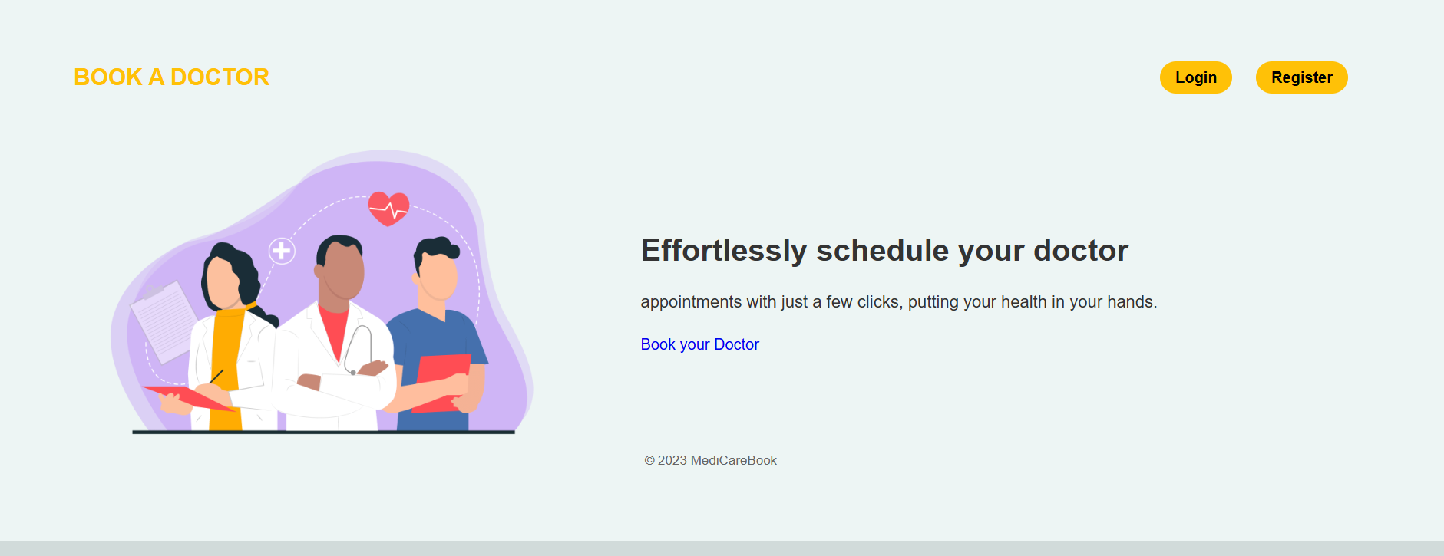
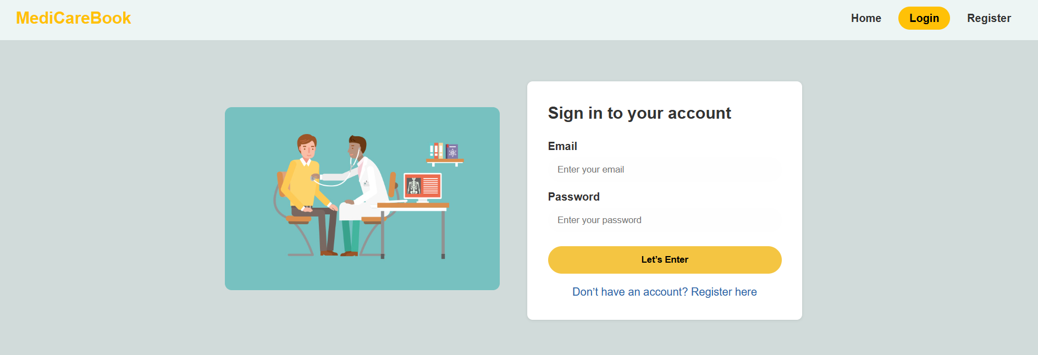
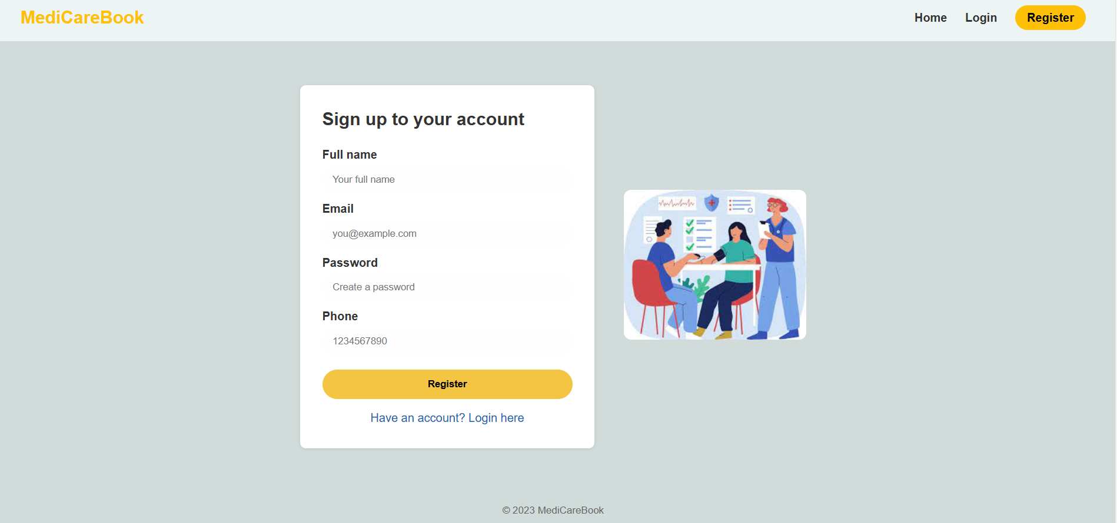
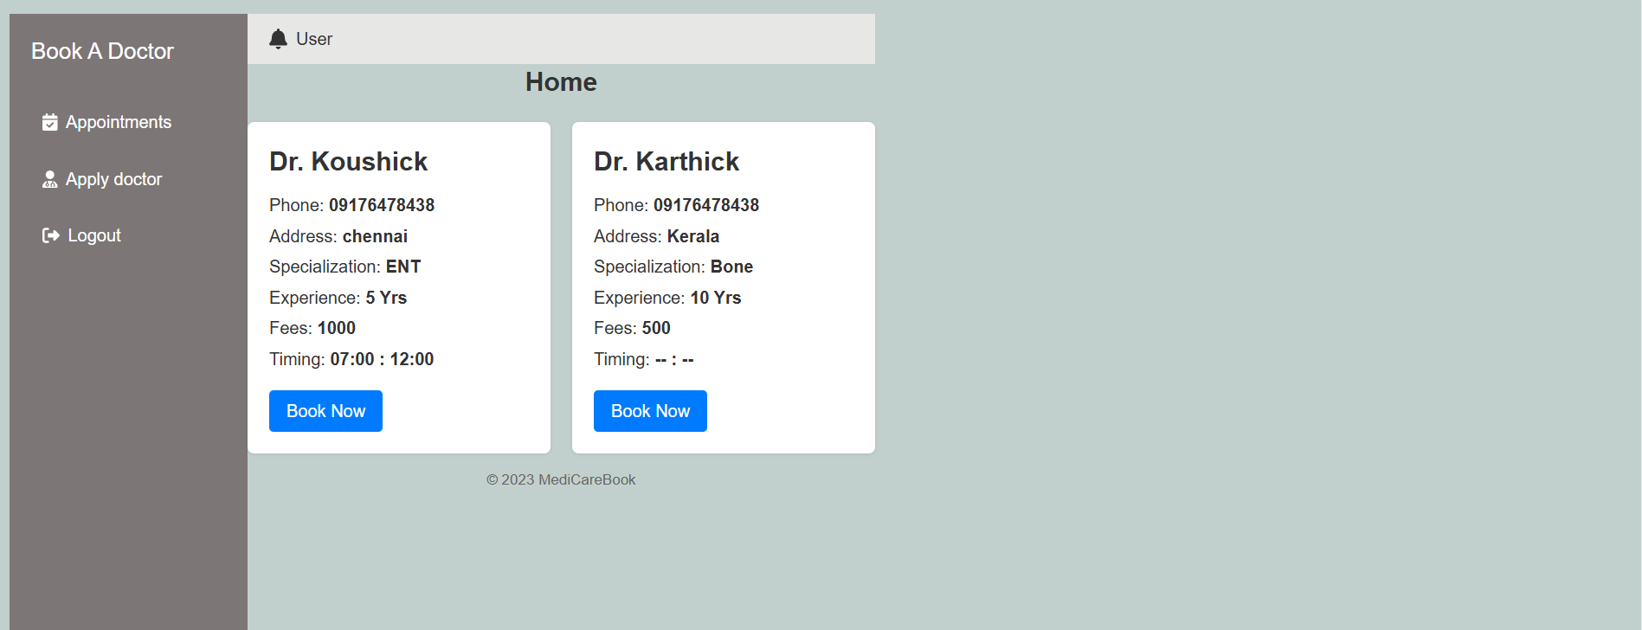

10. Testing
The Docspot app was manually tested across all modules and user roles (Patient, Doctor, Admin). Basic features like login, booking, and appointment updates were verified using browsers.All key functions were tested successfully without errors.
11.Demo
Link:
https://drive.google.com/file/d/1aOcOaQTRR4P1rB2F4NOIcDjgg7NmokWR/view

12. Known Issues
- Possible slot overlap on simultaneous bookings
- No notification system yet
- Some form validations are limited
These do not affect core features and will be addressed in future updates.

13. Future Enhancements
- Add SMS/email notifications for appointments
- Enable video consultations for remote access
- Improve UI with better design and dark mode

